T16 SIM Resource Inventory v5
Interface Specification

Version 1.1.0 ● 09 Nov 2024

Document Version Control
Version | Date | Editor | Change Description
1.0.0 | 09/11/2024 | Patriya Piyawiroj | Document Created
1.1.0 | 27/11/2024 | Patriya Piyawiroj | Added sort and content-range query parameters
1.1.1 | 12/12/2024 | Patriya Piyawiroj | Added default reservation.  Separated List from Query API

Table of Contents

Document Version Control 1
Table of Contents 2
Introduction 3
Overview 4
SIM Diagram 4
TMF Entity Diagram 5
Interface Definition 6
Headers 6
Resource entity 6
SIM Resource Types 8
SIM Card 9
Resource Specification 9
Characteristics 9
Resource Relationships 9
eSIM Profile 9
Resource Specification 10
Characteristics 10
Resource Relationships 11
Logical SIM 11
The Logical SIM (logical resource) represents the attributes of a (physical) SIM card or eSIM that are provisioned 11
during mobile line order execution. 11
Resource Specification 11
Characteristics 11
Resource Relationships 12
Physical SIM 13
The Physical SIM (physical resource) represents the physical SIM card sold to the customer. 13
Resource Specification 13
Characteristics 13
Resource Relationships 13
IMSI 13
Resource Specification 13
Characteristics 13
Resource Relationships 14
MSISDN 14
Resource Specification 14
Characteristics 14
Resource Relationships 14
Sample Operations 15
Query Resource from the inventory: 15
List Resource from the inventory: 15
Update Resource from the inventory: 17
Common Sub-Resource/Entities 18
Note sub-resource 19

Introduction

Overview
This document lists all the services exposed by the Resource Inventory (TMF639 version 5.0) module.

All the services are available using the HTTP and CEDA format.

SIM Diagram
White Boxes - Product
Green Boxes - Resources
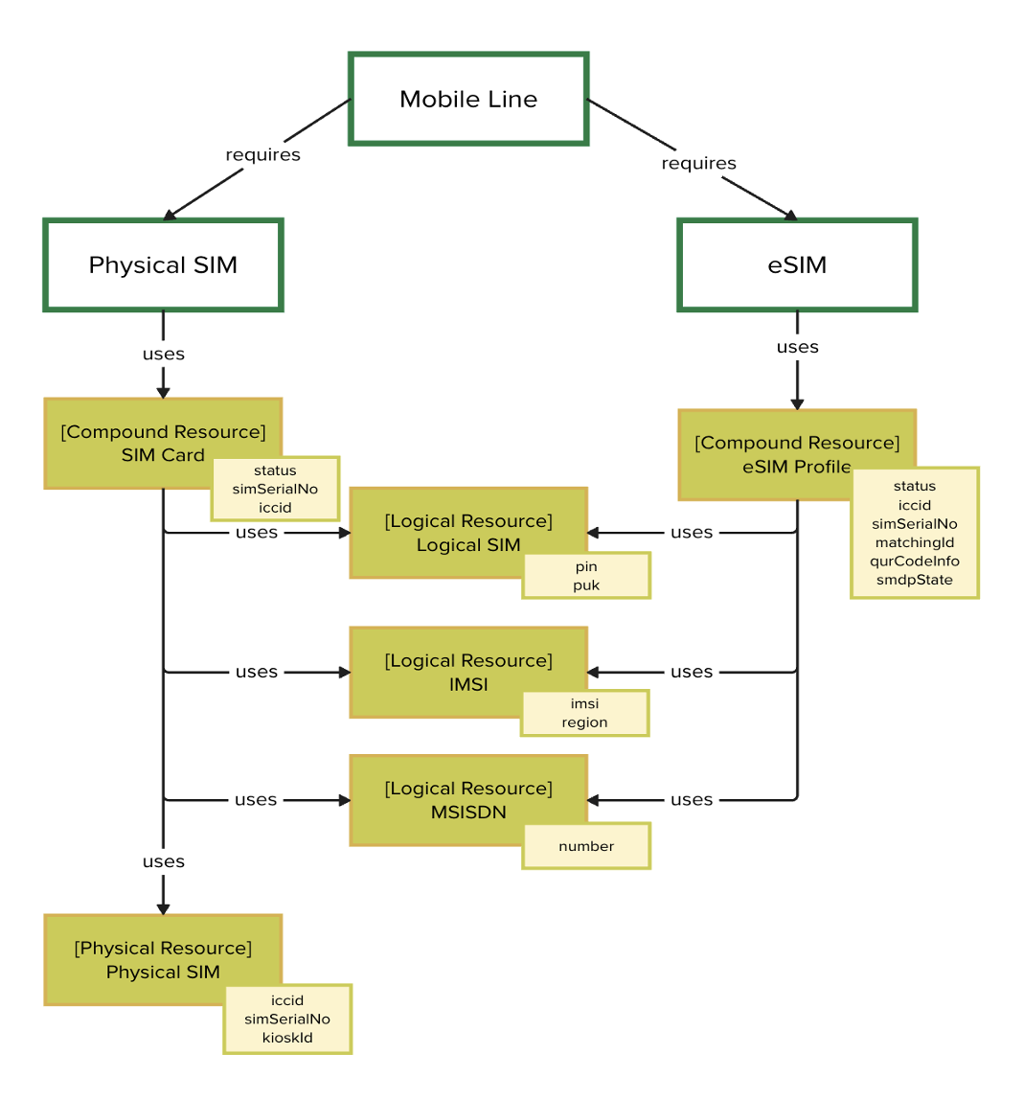

Note that the SMDP profile (downloaded to device) is not included in the diagram because it is managed by the eSIM vendor.
This TMF structure stems from GSMA standards. These names are defined in TMFS008. https://projects.tmforum.org/wiki/display/PUB/TMFS008+Use+Case%3A+Service+and+Resource+Order+Management+for+Postpaid+Mobile+Subscribers+v3.3.0

TMF Entity Diagram

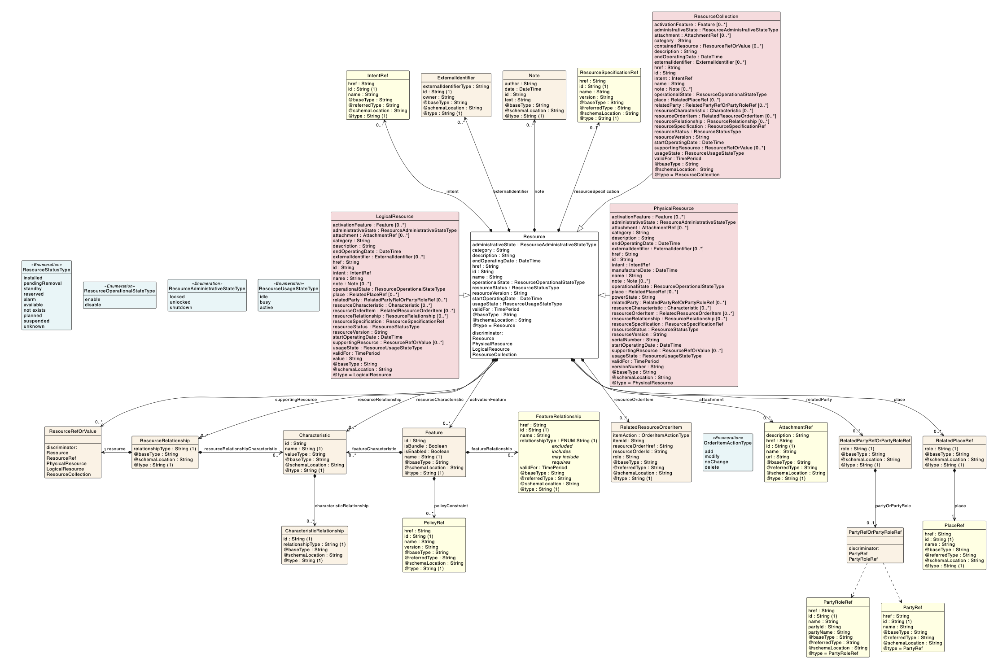
Note that eSIM does not use serialNumber because it is not a physical resource.
ResourceStatus is also not used because the possible values are fixed across all resources.

Interface Definition

The Resource Inventory Management API is defined in the
TMF639-Resource_Inventory_Management-v5.0.0.oas (yaml) Open API specification.

Headers
Request Headers
These are HTTP headers used for logging and monitoring purposes. For Kafka headers, please see T16 CEDA.

Variable | O/M | Type (Location) | Description
Content-Type | M | String | Indicates the body message format. This must be specified to tell the system to expect an array of JSON Patch operations.  Example: Application/json-patch-query+json
useCaseStartTime | O | String | The datetime in which a particular event occurred. See T3 of each business usecase for what to send.  Example: 2024-01-31T00:00:00+07:00
user | M | Object | The user identifier
channel | M | String | The original front end system that initiated the request

Response Headers
Some additional headers are returned for GET APIs.
Variable | O/M | Type | Description
Content-Type | M | String | The content type.  Example: Application/json
X-Total-Count | O | String | Returned for queries. The total number of matching resources. Can be used by the client to calculate the number of pages  Example: 50
Content-Range | O | String | Returned for queries. Describes the range of items returned in the response. Example shows the first 10 items from a total of 50 matched records. Indexed at 0 to match byte format.  Example: items 0-9/50  Example (unsatisifiable range error): items */50

Status Codes
HTTP Response Code | Description
200 | Success
206 | Success (Partial Content). The response body contains the requested range of data.
403 | Forbidden
404 | Data not found
500 | Internal Server error
501 | Not implemented. Unsupported filter.

Resource entity
Field |  |  | O/M | Type (Length) | Description
id |  |  | M | String | Unique identifier of the resource
href |  |  | M | String | Hyperlink reference to the resource.  Example: /resourceInventory/v5/eSimProfile/42
name |  |  | M | String | Name of the resource  Example: Sim Card
note |  |  | O | Array of Note | Note. Extra-information about the resource; e.g. useful to add extra information that could be useful for a human process.
 | id |  | O | String | The running number of the note within the array.
 | author |  | O | String | The person/user that created the note
 | date |  | O | String | The date the note was created
 | text |  | O | String | The text value of the note
 | @type |  | O | String | This defines the class name or sub-class  Value: "Note"
resourceRelationship |  |  | O | Array of ResourceRelationship | A list of resources related to this resource. The fields inside are Mandatory only when the resourceRelationship object exists.
 | relationshipType |  | M/O | String | The type of related order, such as: [uses] if the resource relies on or consumes the functionality of another entity (e.g. a SIM “uses” an IMSI and MSISDN for its operations within the mobile network)
 | resource |  | M/O | ResourceRefOrValue | A reference to the related resource.
 |  | id | M/O | String | Unique identifier of the resource
 |  | href | M/O | String | Hyperlink reference
 |  | @referredType | M/O | String | The class name of the related resource  Example: Imsi
 |  | @type | M/O | String | Type of the resource  Example: ResourceRef
 | @type |  | M/O | String | This defines the class name or sub-class Extensible name  Value: ResourceRelationship
resourceCharacteristic |  |  | M | Array of Characteristic | Describes a given characteristic of the resource through a name/value pair.  The possible characteristics depends on the SIM Resource Types. (SIM Card will have difference characteristics from eSIM Profile)  This is an abstract base class, the actual value is in one of the strongly-typed subclasses (see @type)
 | name |  | M | String | Name of the characteristic
 | value |  | M | String | Value of the characteristic
 | valueType |  | M | String | Data type of the value of the characteristic.  A more descriptive/specific version of the type of the characteristic. This is custom defined and can help clients create custom logic to handle each characteristic differently.
 | @type |  | M | String | One of: StringCharacteristic, ObjectCharacteristic, FloatCharacteristic, BooleanCharacteristic, NumberCharacteristic, IntegerCharacteristic,StringArrayCharacteristic, ObjectArrayCharacteristic,BooleanArrayCharacteristic, NumberArrayCharacteristic, IntegerArrayCharacteristic...
relatedParty |  |  | M/O | Array of RelatedPartyRef | Parties such as customers and organizations related to this resource
 | role |  | M/O | String | Role of the related party in relation to this resource (e.g. owner, vendor)
 | partyOrPartyRole |  | M/O | PartyRef | A reference to the party information in party domain
 |  | id | M/O | String | The id of the party
 |  | name | M/O | String | The name of the party  Example: AWN
 |  | href | M/O | String | Hyperlink reference  Example: /partyManagement/v5/organization
 |  | @type | M/O | String | This defines the class name or sub-class Extensible name  Value: PartyRef
 |  | @referredType | M/O | String | The class name of the related resource  Example: Organization
 | @type |  | M/O |  | This defines the class name or sub-class Extensible name  Value: ResourceRelationship
@baseType |  |  | O | String | When sub-classing, this defines the super-  class.  Value: "Resource"
@type |  |  | M | String | This defines the class name or sub-class Extensible name  Value: "Imsi"

SIM Resource Types

SIM Card

The SIM card compound resource consists of a physical SIM (selected during order capture or shipped to customer during product order processing) and a Logical SIM (which is provisioned during the order execution).

Resource Specification
Field | Description
name | SIM Card
category | Network Connectivity
description | The SIM card compound resource consists of a physical SIM (selected during order capture or shipped to customer during product order processing) and a Logical SIM (which is provisioned during the order execution).
version | 1.0
path | /simCard
type | SimCard

Characteristics
Greyed out fields are duplicated from the associated resource relationship

Name | Is Unique | Configurable | Extensible | Value Type | Description
status | No | Yes | N/A | String | Status Code.  Possible values:  • PendingPerso  • Available  • Cancelled  • Expired  • Write Off  • Pending PortIn  • Pending Prepaid Iden  • Pending Preparation  • Pending Recall  • Pending Registration  • PendingPerso  • Prematch  • Prepaid Iden  • Registered  • Reserved  • Transfer Pre-paid  Alternate name: status_code
simSerialNo | See Physical SIM
Iccid | See Physical SIM
regionCode | See IMSI
number | See MSISDN
networkCode | See Logical SIM
capacity | See Logical SIM
simVersion | See Logical SIM

Resource Relationships
Name | RelationshipType | Role | Description
Logical SIM | uses | N/A | This resource provides attribute(s) that are provisioned during order execution
Physical SIM | uses | N/A | The resource represents the physical SIM
IMSI | uses | N/A | An International Mobile Subscriber Identity - a unique number used to identify a mobile subscriber in a cellular network.
MSISDN | uses | N/A | The mobile number associated with the SIM

eSIM Profile

The eSIM Profile logical resource is the provisioning view of the corresponding profile being downloaded to the end
user equipment

Resource Specification
Field | Description
name | eSIM Profile
category | Network Connectivity
description | The eSIM Profile logical resource is the provisioning view of the corresponding profile being downloaded to the end  user equipment
version | 1.0
path | /eSimProfile
type | ESimProfile

Characteristics
Greyed out fields are duplicated from the associated resource relationship

Name | Is Unique | Configurable | Extensible | Value Type | Description
eid | Yes | Yes | N/A | String | [StringCharacteristic]  “Embedded Identity Document” is a serial number corresponding to the eSIM installed in a connected device. The eSIM vendor contains this information and will send this value to AIS when the eSIM is installed on the user device.
smdpState | No | Yes | N/A | String | [StringCharacteristic]  The state of the eSIM Profile. When the eSIM profile state is changed (e.g. eSIM Profile is downloaded by user) a notification is sent from the eSIM vendor to AIS, and the state is tracked in the esim table.  Possible values:  • Downloaded  • Installed  • Deleted  • Enable  • Disable  Alternate name: esim.status_code
iccid | Yes | Yes | N/A | String | [StringCharacteristic]  A 19 digit Integrated Circuit Card Identifier, uniquely identifies the SIM Card (UICC) on the network. For eSIMs, this number is maintained by the eSIM vendor, but its value is determined by AIS.  When eSIMs are bought in batches from the vendor, AIS increments the running number of eSIMs kept as CMSE. Each number is prefixed with “896603” and then sent to the vendor to be set on the eSIM.
matchingId | Yes | Yes | N/A | String | [StringCharacteristic]  A unique identifier used by the SMDP+ server to match a specific eSIM profile to the request made by the Local Profile Assistant (LPA) on the device.
simSerialNo | Yes | Yes | N/A | String | [StringCharacteristic]  A 13 digit serial number tied to the physical SIM on procurement. For eSIMs, this a running number used to generate the iccid. Can not be changed.  Alternate name: sim.serial_no
smdpAddress | No | Yes | N/A | String | [StringCharacteristic]  The server URL of the vendor system managing eSIM profiles. This value is not stored in the database but is calculated by the app using the value of qrCodeInfo without the matchingId.
status | No | Yes | N/A | String | [StringCharacteristic]  Status Code.  Possible values:  • PendingPerso  • Available  • Cancelled  • Expired  • Write Off  • Pending PortIn  • Pending Prepaid Iden  • Pending Preparation  • Pending Recall  • Pending Registration  • PendingPerso  • Prematch  • Prepaid Iden  • Registered  • Reserved  • Transfer Pre-paid  Alternate name: sim.status_code
qrCodeInfo | Yes | Yes | N/A | String | Contains QR Code information used to download the eSIM profile. Is acquired along with the eSIM when bought from vendor (ECP). Unique to eSIMs.  Format: SMDPAddress concatenated with matchingId.
regionCode | See IMSI
number | See MSISDN
networkCode | See Logical SIM
capacity | See Logical SIM
simVersion | See Logical SIM

Resource Relationships
Name | RelationshipType | Role | Description
Logical SIM | uses | N/A | This resource provides attribute(s) that are provisioned during order execution
IMSI | uses | N/A | An International Mobile Subscriber Identity - a unique number used to identify a mobile subscriber in a cellular network.
MSISDN | uses | N/A | The mobile number associated with the SIM

Related Parties
role | Description
owner | The company that owns the sim  Example: AWN
vendor | The eSIM vendor  Example: ECP

Logical SIM

The Logical SIM (logical resource) represents the attributes of a (physical) SIM card or eSIM that are provisioned

during mobile line order execution.

Resource Specification
Field | Description
name | Logical SIM
category | Network Connectivity
description | The Logical SIM (logical resource) represents the attributes of a (physical) SIM card or eSIM that are provisioned  during mobile line order execution.
version | 1.0
path | /logicalSim
type | LogicalSim

Characteristics
Name | Is Unique | Configurable | Extensible | Value Type | Description
accValue | No | Yes | N/A | String | [StringCharacteristic]  The Access Control Class of the SIM
adm1 | No | Yes | N/A | String | [StringCharacteristic]  The Administrative Key is a cryptographic key used for managing security-related operations on the SIM card, such as changing PIN codes, unlocking the card, or updating security settings
algorithm | No | Yes | N/A | String | [StringCharacteristic]  The cryptographic algorithm used to generate  and verify the EOPC. For example: Hash functions like SHA-256 (Secure Hash Algorithm 256-bit) or SHA-3 (Secure Hash Algorithm 3) for generating a unique hash  value from input data. Symmetric encryption algorithms like AES (Advanced Encryption Standard) for encrypting  and decrypting data securely. Asymmetric encryption algorithms like RSA (Rivest-Shamir-Adleman) for secure  communication and key exchange between the device and the operator's servers.
capacity | No | Yes | N/A | String | [StringCharacteristic]  SIM Capacity  (e.g. "capacityCode" : "64k")
cardProfile | No | Yes | N/A | String | [StringCharacteristic]  SIM Electrical Profile. A code which contains information on the card type, vendor, features (OTA, 5G, etc.). This is used to distinguish between different SIM Specifications and is manually assigned in by a user on SFF.
eki | No | Yes | N/A | String | [StringCharacteristic]  The EKI (Encrypted Key Indicator) refers to a piece of information used in the process of securely exchanging encryption keys between the mobile device (such as a smartphone) and the mobile network operator's systems during over-the-air operations.
eopc | No | Yes | N/A | String | The Ephemeral Operator Provisioning Code is a temporary code that is used during the provisioning process of a SIM profile. It serves as a secure means for the device to authenticate and establish a connection with the mobile network operator's systems in order to download the necessary subscription information and configuration settings.
k4id | No | Yes | N/A | String | [StringCharacteristic]  The Key for Identity (K4ID) is a cryptographic key used in SIM cards and eSIMs for identity authentication and security purposes. The K4ID is one of the keys stored on the SIM card or eSIM profile and is used to generate authentication tokens and signatures during various security-related operations. It plays a crucial role in verifying the identity of the mobile device (such as a smartphone
kic | No | Yes | N/A | String | [StringCharacteristic]  The KIC (Key Encryption Key) is a cryptographic key used in SIM cards and eSIMs for securing communication between the mobile device and the mobile network operator's systems. Specifically, the KIC is used to encrypt data exchanged during authentication and over-the-air operations.
kycSupported | No | Yes | N/A | Boolean | [StringCharacteristic]  A flag that indicates whether this SIM supports eKYC. If yes, the customer can use eKYC as a means to verify their information after prematching stage.  Alternate name: sim.kyc_flag
networkCode | No | Yes | N/A | String | [StringCharacteristic]  Also known as operator code. Used to identify the SIM’s telecom operator / service provider within a network. A numbered code e.g. 03
networkName | No | Yes | N/A | String | [StringCharacteristic]  The name of the operator/service provider. For example the 03 network code maps to “AWN”. Mapped from networkCode.
otaKey | No | Yes | N/A | String | [StringCharacteristic]  The OTA (Over-The-Air) key, also known as an OTA cryptographic key, is a security feature used in mobile networks, particularly in the context of SIM cards and eSIMs. This key is used to securely authenticate and encrypt communication between the mobile device (such as a smartphone) and the mobile network operator's systems during over-the-air operations.
pin1 | No | Yes | N/A | String | [StringCharacteristic]  This is the primary PIN associated with a SIM card. It is used to protect access to basic functionalities of the SIM card, such as making phone calls, sending SMS messages, and accessing mobile data services. Whenever the device is powered on or the SIM card is  inserted, the user typically needs to enter the PIN1 to unlock the SIM card and gain access to these basic services
pin2 | No | Yes | N/A | String | [StringCharacteristic]  This is a secondary PIN used to secure access to more sensitive or advanced functionalities on the SIM card. It is primarily used for accessing functions related to the SIM card's supplementary services, such as call forwarding, call barring, changing the PIN1, and accessing the fixed dialing list (FDN). PIN2 is required when performing operations that may have a greater impact on the subscriber's account or privacy
puk1 | No | Yes | N/A | String | [StringCharacteristic]  PUK1 is used to unlock the SIM card when the primary PIN (PIN1) has been entered incorrectly multiple times. When a user enters an incorrect PIN1 several times in a row (usually three to ten times, depending on the mobile network operator's policy), the SIM card becomes locked, and the user is prompted to enter the PUK1 to unlock it. Entering the correct PUK1 allows the user to reset the PIN1 and regain access to the SIM card's basic functionalities.
puk2 | No | Yes | N/A | String | [StringCharacteristic]  PUK2 is used to unlock supplementary services and functions on the SIM card when the secondary PIN (PIN2) has been entered incorrectly multiple times. Similar to PUK1, when a user enters an incorrect PIN2 several times in a row, the SIM card may become locked, requiring the user to enter the PUK2 to unlock access to functions such as call barring, call forwarding, and the fixed dialing list (FDN).
simProfile | No | Yes | N/A | String | [StringCharacteristic]  A system profile used to categorise the SIM in to different capabilities
simVersion | No | Yes | N/A | String | [StringCharacteristic]  Minimum support Version of SIM  (e.g. "simVersion" : "3G")

Resource Relationships
None

Physical SIM

The Physical SIM (physical resource) represents the physical SIM card sold to the customer.

Resource Specification
Field | Description
name | Logical SIM
category | Network Connectivity
description | The Physical SIM (physical resource) represents the physical SIM card sold to the customer.
version | 1.0
path | /physicalSim
type | PhysicalSim

Characteristics
Name | Is Unique | Configurable | Extensible | Value Type | Description
iccid | Yes | Yes | N/A | String | [StringCharacteristic]  A 19 digit Integrated Circuit Card Identifier, uniquely identifies the SIM Card (UICC) on the network. For physical SIMs, this value the simSerialNo prefixed with “896603”  Example: 8966030000000000000
simSerialNo | Yes | Yes | N/A | String | [StringCharacteristic]  A 13 digit serial number tied to the physical SIM on procurement.  Alternate name: sim.serial_no

Resource Relationships
None

IMSI
International Mobile Subscriber Identity. A unique number used to identify a mobile subscriber in a cellular network. May come with or without the SIM depending on the vendor. For vendors such as Gemalto, the IMSI comes with the SIM. For vendors such as ECP, the IMSI life cycle must be managed by AIS separately.

Resource Specification
Field | Description
name | IMSI
category | Network Connectivity
description | International Mobile Subscriber Identity. A unique number used to identify a mobile subscriber in a cellular network.
version | 1.0
path | /imsi
type | Imsi

Characteristics
Name | Is Unique | Configurable | Extensible | Value Type | Description
imsi | Yes | Yes | N/A | String | [StringCharacteristic]  Value of IMSI
dummyImsi | No | Yes | N/A | String | [StringCharacteristic]  The dummy IMSI used when preprovisioning the SIM
region | No | Yes | N/A | String | [StringCharacteristic]  Region. Defined as a 2 digit code e.g. C3  Alternate Name: parent_region
regionCode | No | Yes | N/A | String | [StringCharacteristic]  A 5 digit code that specifies a region in Thailand. After Perso SIM when SIM is associated with an IMSI, the region of the SIM will depend on the parent region of the IMSI. Also stored in sim.  Format: XX001  Where the first two letters represent the region (e.g. CW=Central West, NX=North). The first two numbers specifies a specific place within the region. The last number is 0 if is a postpaid SIM, and 9 or empty if is prepaid. The default value is prepaid.  Mobile Region Code  Remark:  1. mandatory when actionType = “requestESIM”  2. if client input this value, PGZINV will use it to random eSIM normal (Gemalto)  3. for dynamic eSIM (ECP), PGZINV cannot random by using regionCode because dynamic eSIM doesn’t has the imsi.  4. for actionType “randomImsiForESIM”,  if client send only mobileNo (no regionCode), PGZINV will use mobileNo and simService send to SFF for random imsi.  **client will send regionCode = 5 digits to randomImsiForESIM, PGZINV will pass this value to SFF **
regionName | No | Yes | N/A | String | The spelled out name of the region. For example “Central”

Resource Relationships
May have a two way relationship back to the SIM with “usedBy”

MSISDN

Mobile Station International Subscriber Directory Number. It is the unique phone number assigned to a mobile subscriber for identification and communication in a mobile network.

Resource Specification
Field | Description
name | MSISDN
category | Network Connectivity
description | Mobile Station International Subscriber Directory Number. It is the unique phone number assigned to a mobile subscriber for identification and communication in a mobile network.
version | 1.0
path | /msisdn
type | Msisdn

Characteristics
Name | Is Unique | Configurable | Extensible | Value Type | Description
number | Yes | Yes | N/A | String | The current active mobile number used by the SIM.

Resource Relationships
None

Sample Operations

Query Resource:
Description: This operation gets information of a single eSIM and SIM. Used for singular queries only. The resource ID must be known, and a 404 error will be thrown if the resource ID is not found. As such, query parameters are not applicable and only one response object will be returned.
Methods: GET
Request URI (eSIM): /resourceInventory/v5/eSimProfile/{resourceId}
Request URI (physical SIM): /resourceInventory/v5/simCard/{resourceId}

Response Example:
{
"id": "be665c24-0c48-4bdd-8b69-e4790cee1d88",
"name": "eSim Profile ",
"note": [
{
"id": "1",
"text": "Insert by API simSerialNoPortIn because sim not perso by PHX",
"@type": "Note"
}
],
"resourceCharacteristic": [
{
"name": "simSerialNo",
"value": "2140115870164",
"valueType": "String",
"@type": "StringCharacteristic"
}
],
"resourceRelationship": [
{
"relationshipType": "uses",
"resource": {
"id": "8655",
"href": "resourceInventory/v5/resource/8655",
"@referredType": "Imsi",
"@type": "ResourceRef"
},
"@type": "ResourceRelationship"
}
]
"@type": "ESimProfile"
}

List Resource:
Description: This operation gets information of an eSIM and SIM
Methods: GET
Request URI (eSIM): /resourceInventory/v5/eSimProfile
Request URI (physical SIM): /resourceInventory/v5/simCard

Query Parameters:
Variable | O/M | Type | Description
fields | O | List of String (Query Parameter) | A TMF concept that filters the response to only include the fields requested. Accepts a list of values beginning with “resource”.  Format: {field1},{field2}, ….  Sample Value: resourceCharacteristic  If left empty, all fields in database will be returned. Use to reduce payload size.  Regardless of the filter, the “id”, “href” field will always be returned.
filter | O | String | Matches the documents with this JSON Patch filter. Unsupported filters will return 501 Not Implemented as per TMF630 Part 5 guidelines.  Singular: ?filter=$.resourceCharacteristic[?(@.name=’simSerialNo’&&@.value=8966032140115870164)]  Range: ?filter=$.resourceCharacteristic[?(@.name=’simSerialNo’&&@.value>=8966032140115870164&&@.value<8966032140115870164)]  Multiple: ?filter=$.resourceCharacteristic[?(@.name=’simSerialNo’&& @.value in [1, 2, 3])]  Supports the following names:  • simSerialNo  • iccid  • status  • networkCode  • capacity  • regionCode  • prepMobileNo  • simVersion  JSON Path also accepts range (>=, >, <, <=) and equivalence (==, !=) queries.
note.text | O | String | Queries a SIM with the given remark  Example: ?note.text=’Change SIM’  Alternate name: sim.remark
limit | O | String | Requested number of resources to be provided in response requested by client. If limit isn’t specified, default is 100, and max is 500. Exceeding max will not result in error, but only a maximum of 500 will be returned.  Example: ?limit=100
offset | O | String | Requested index for start of resources to be provided in response requested by client  Example ?offset=10&limit=20  Gets 20 resources starting with the 10th
expand | O | String | A list of fields to expand. Used to limit expands. If this is not specified, all fields and the given depth will be expanded.  Example: ?expand=resourceInventory.resourceRelationship
depth | O | String | The number of depths to expand.  If depth is not specified, then the default value will depend on the expand parameter. If expand parameter is set, then depth is 1. If not set, then 0.  Examples:  • ?depth=0, none of the ids and hrefs will be expanded  • ?depth=1, Replaces all hrefs at the resource level  • ?depth=2, Replaces all hrefs in variables of resource (e.g. resource.resourceRelationship  • ?depth=3, (e.g. resource.resourceRelationship.resource)  • depth of 4 and more will throw 501 Unsupported error
sort |  |  | Sorts the results by a field. Supports JSON Path sorting for characteristics  Example:  • ?sort=id (Sort the result set on id)  • ?sort=-id (Sort the result set on id in descending order)  • ?sort=resourceCharacteristic[?(@.name==”simSerialNo”)].value  • ?sort=id,resourceCharacteristic[?(@.name==”createdDate”)].value (Sort by multiple parameters)

Response Example:
[
{
"id": "be665c24-0c48-4bdd-8b69-e4790cee1d88",
"name": "eSim Profile ",
"note": [
{
"id": "1",
"text": "Insert by API simSerialNoPortIn because sim not perso by PHX",
"@type": "Note"
}
],
"resourceCharacteristic": [
{
"name": "simSerialNo",
"value": "2140115870164",
"valueType": "String",
"@type": "StringCharacteristic"
}
],
"resourceRelationship": [
{
"relationshipType": "uses",
"resource": {
"id": "8655",
"href": "resourceInventory/v5/resource/8655",
"@referredType": "Imsi",
"@type": "ResourceRef"
},
"@type": "ResourceRelationship"
}
]
"@type": "ESimProfile"
}
]

Update Resource:
Description: This operation updates a SIM
Kafka Topic (Consume eSIM): esb.prd.updateEsimProfile
Kafka Topic (Produce eSIM): esb.prd.esimProfileUpdated
Kafka Topic (Consume sim card): esb.prd.updateSimCard
Kafka Topic (Produce sim card): esb.prd.simCardUpdated

Request Example:

JavaScript Object Notation (JSON) [RFC4627] is a common format for the exchange and storage of structured data. HTTP PATCH [RFC5789] extends the Hypertext Transfer Protocol (HTTP) [RFC2616] with a method to perform partial modifications to resources.

Please refer to this example for patching resource characteristics:
[{
"op": "replace",
"path": "resourceCharacteristic/value?resourceCharacteristic.name=status",
"value": "Available"
},{
"op": "replace",
"path": "resourceCharacteristic/value?resourceCharacteristic.name=smdpState",
"value": "Installed"
}, {
"op": "replace",
"path": "relatedParty/partyOrPartyRole/name?relatedParty.role=owner",
"value": "AWN"
},
{
"op": "replace",
"path": "relatedParty/partyOrPartyRole/name?relatedParty.role=vendor",
"value": "ECP"
},
]

And refer to this example for adding/removing a resource relationship:
,[{
"op": "add",
"path": "resourceRelationship ",
"value": {
“relationshipType”: “uses”,
“resource”: {
“id”: “”,
“@type”: “MSISDN”
}
}
}]

Response Example:
[{
"op": "replace",
"path": "resourceCharacteristic/value?resourceCharacteristic.name=status",
"value": "Reserved"
},{
"op": "add",
"path": "resourceRelationship ",
"value": {
“relationshipType”: “uses”,
“resource”: {
“id”: “”,
“@type”: “IMSI”
}
}
},{
"op": "add",
"path": "resourceRelationship ",
"value": {
“relationshipType”: “uses”,
“resource”: {
“id”: “”,
“@type”: “MSISDN”
}
}
}]

Create Resource:
Description: This operation creates a SIM
Kafka Topic (Consume eSIM): esb.prd.createEsimProfile
Kafka Topic (Produce eSIM): esb.prd.esimProfileCreated
Kafka Topic (Consume sim card): esb.prd.createSimCard
Kafka Topic (Produce sim card): esb.prd.simCardCreated

Request Example:
{
"name": "eSim Profile ",
"note": [
{
"id": "1",
"text": "Insert by API simSerialNoPortIn because sim not perso by PHX",
"@type": "Note"
}
],
"resourceCharacteristic": [
{
"name": "simSerialNo",
"value": "2140115870164",
"valueType": "String",
"@type": "StringCharacteristic"
}
],
}

Response Example:
{
"id": "be665c24-0c48-4bdd-8b69-e4790cee1d88",
"name": "eSim Profile ",
"note": [
{
"id": "1",
"text": "Insert by API simSerialNoPortIn because sim not perso by PHX",
"@type": "Note"
}
],
"resourceCharacteristic": [
{
"name": "simSerialNo",
"value": "2140115870164",
"valueType": "String",
"@type": "StringCharacteristic"
}
]
"@type": "ESimProfile"
}

Delete Resource:
Description: Hard deletes a resource
Methods: DELETE
Request URI (eSIM): /resourceInventory/v5/eSimProfile/{resourceId}
Request URI (physical SIM): /resourceInventory/v5/simCard/{resourceId}

Response Example:
200 Success

Common Sub-Resource/Entities

Note sub-resource
Field | O/M | Type (Length) | Description
id | O | String | The running number of the note within the array.
author | O | String | The person/user that created the note
date | O | String | The date the note was created  Format: date-time FRC3339
text | O | String | The text value of the note
@type | O | String | This defines the class name or sub-class  Value: "Note"

